**Chapter 5**

**Multiple Integration**

**5.7 Change of Variables in Multiple Integrals**

**Section Exercises**

**In the following exercises, the function  on the region bounded by the unit squareis given, where is the image of under.**

1. **Justify that the function  is a  transformation.**
2. **Find the images of the vertices of the unit square  through the function.**
3. **Determine the image  of the unit square  and graph it.**

Answer: This is a proof; therefore, no answer is provided.

356. 

Answer: a.  and  The functions  and  are continuous and differentiable, and the partial derivatives   and  are continuous on; b.   and  c.  is the rectangle of vertices,  in the; see the following figure.

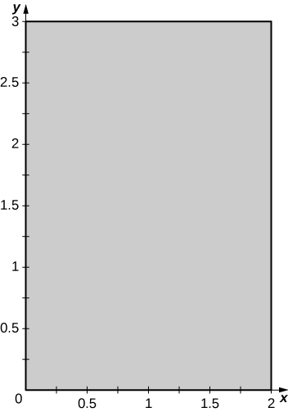

357. 

Answer: a.  and . The functions  and  are continuous and differentiable, and the partial derivatives,  are continuous on  b. ,  and ; c. is the rectangle of vertices  in the the following figure.

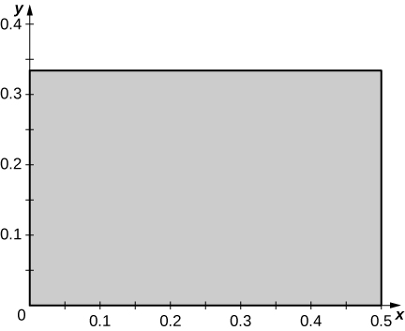

358. 

Answer: a.  and . The functions  and  are continuous and differentiable, and the partial derivatives  are continuous on; b.  and ; c.  is the square of vertices  in the; see the following figure.

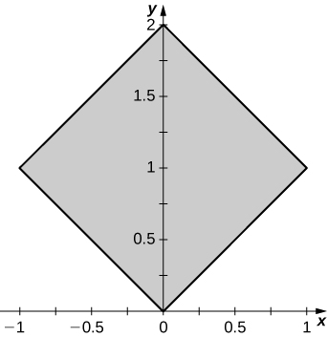

359. 

Answer: a. , and . The functions  and  are continuous and differentiable, and the partial derivatives , ,, and  are continuous on; b. ,,, and; c.  is the parallelogram of vertices in the see the following figure.

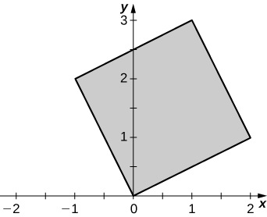

360. 

Answer: a. , and . The functions  and  are continuous and differentiable, and the partial derivatives, ,, and  are continuous on; b. , , and ; c.  is the unit square in the see the following figure.

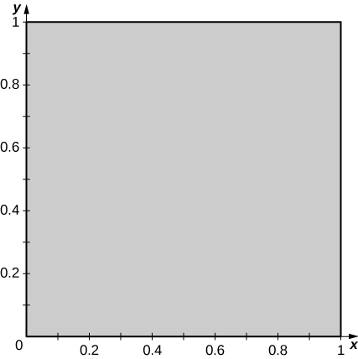

361. 

Answer: a. , and. The functions  and  are continuous and differentiable, and the partial derivatives , ,, and  are continuous on ; b. , , and ; c.  is the unit square in the see the figure in the answer to the previous exercise.

**In the following exercises, determine whether the transformations  are one-to-one or not.**

362.  is the rectangle of vertices

Answer:  is not one-to-one: two points of  have the same image. Indeed, 

363.  is the triangleof vertices 

Answer:  is not one-to-one: two points of  have the same image. Indeed, 

364. is the square of vertices

Answer:  is one-to-one: We argue by contradiction.  implies  and . Thus, and .

365. , where  is the triangle of vertices 

Answer:  is one-to-one: We argue by contradiction.  implies  and. Thus,  and .

366.  where 

Answer:  is one-to-one: We argue by contradiction.  implies  Thus, 

367.  where 

Answer:  is not one-to-one: 

**In the following exercises, the transformations  are one-to-one. Find their related inverse transformations **

368.  where 

Answer: 

369.  where 

Answer: 

370.  where  and 

Answer:

371.  where  and 

Answer: 

372.  where 

Answer: 

373.  where 

Answer:

**In the following exercises, the transformation  and the region are given. Find the region .**

374. , where 

Answer:

375. , where

Answer: 

376.  , where 

Answer: 

377. , where

Answer: 

**In the following exercises, find the Jacobian  of the transformation.**

378. 

Answer:

379. 

Answer: 

380. 

Answer:

381. 

Answer: 

382. 

Answerz

383. 

Answer:

384. 

Answer: 

385. 

Answer:

386. 

Answer:

387. 

Answer:

388. The triangular region  with the vertices  is shown in the following figure.

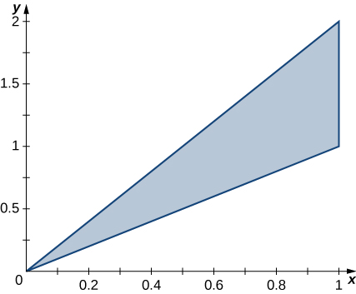

1. Find a transformation  where , and  are real numbers with  such that  and 
2. Use the transformation  to find the area  of the region.

Answer: a.; b. The area of  is

389. The triangular region  with the vertices is shown in the following figure.

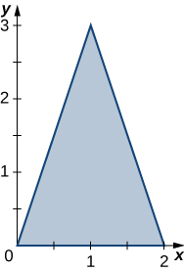

1. Find a transformation   where  and  are real numbers with  such that (0, 0) = (0, 0), and , and .
2. Use the transformation  to find the area  of the region.

Answer: a. ; b. The area of  is .

**In the following exercises, use the transformation , to evaluate the integrals on theparallelogram  of vertices shown in the following figure.**

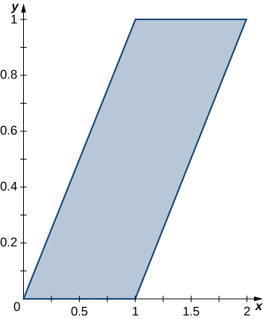

390. 

Answer:

391. 

Answer: 

**In the following exercises, use the transformation  to evaluate the integrals on thesquare  determined by the lines and  shown in the following figure.**

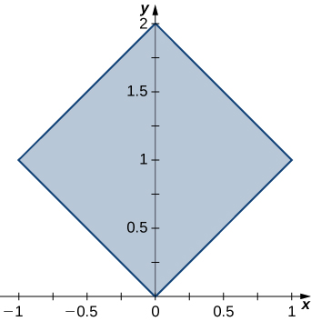

392. 

Answer:

393. 

Answer:

**In the following exercises, use the transformation  to evaluate the integrals on the region  bounded by the ellipse  shown in the following figure.**

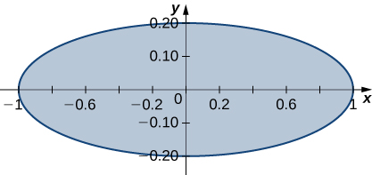

394. 

Answer: 

395. 

Answer:

**In the following exercises, use the transformation  to evaluate the integrals on the trapezoidal region  determined by the points shown in the following figure.**

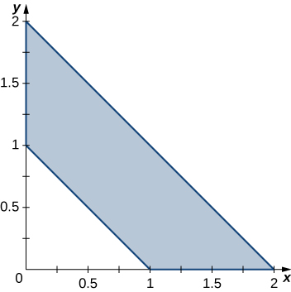

396. 

Answer: 

397. 

Answer: 

398. The circular annulus sector  bounded by the circles  and , the line , and the  is shown in the following figure. Find a transformation  from a rectangular region  in the -plane to the region  in the plane. Graph.

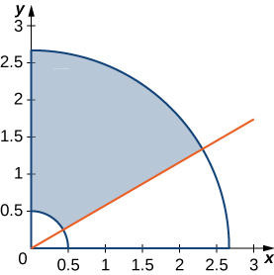

Answer: . The region in the-plane is graphed in the following figure.

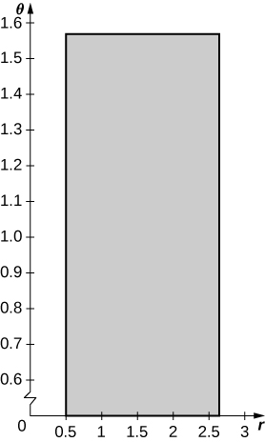

399. The solid  bounded by the circular cylinder  and the planes   is shown in the following figure. Find a transformation  from a cylindrical box  in space to the solid  in space.

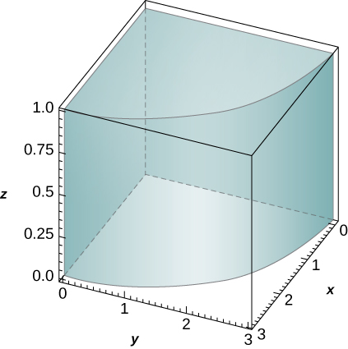

Answer:  in thespace

400. Show that , where  is acontinuous function on  and  is the region bounded by the ellipse.

Answer: This is a proof; therefore, no answer is provided.

401. Show that , where  is acontinuous function on  and  is the region bounded by the ellipsoid

Answer: This is a proof; therefore, no answer is provided.

402. **[T]** Find the area of the region bounded by the curves  and by using the transformation  and . Use a computer algebra system (CAS) to graph the boundary curves of the region.

Answer: The area of is ; the boundary curves of  are graphed in the following figure.

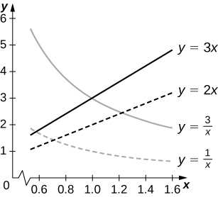

403. **[T]** Find the area of the region bounded by the curves  and  by using the transformation  and . Use a CAS to graph the boundary curves of the region.

Answer: The area of  is ; the boundary curves of  are graphed in the following figure.

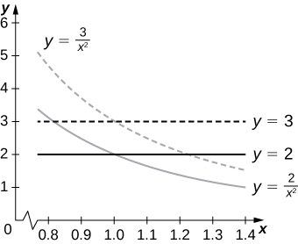

404. Evaluate the triple integral  by using the transformation , .

Answer:

405. Evaluate the triple integral  by using the transformation 

Answer:

406. A transformation of the form  where are real numbers, is called linear. Show that a linear transformation for which  maps parallelograms to parallelograms.

Answer: This is a proof; therefore, no answer is provided.

407. The transformation where  is called a rotation of angle . Show that the inverse transformation of  satisfies, where is the rotation of angle .

Answer: This is a proof; therefore, no answer is provided.

408. **[T]** Find the region  in the  whose image through a rotation of angle  is the region  enclosed by the ellipse . Use a CAS to answer the following questions.

1. Graph the region.
2. Evaluate the integral . Round your answer to two decimal places.

Answer: a. *S* is the region bounded by the ellipse  and is graphed in the following figure.

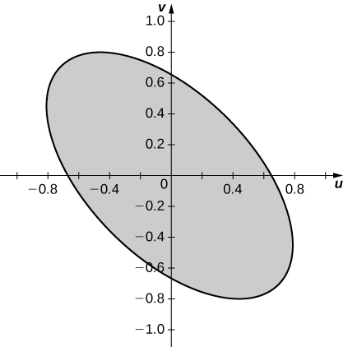

409. **[T]** The transformations   defined by   and are called reflections about the  origin, and the line, respectively.

1. Findthe image of the region in the  through the transformation 
2. Use a CAS to graph.
3. Evaluate the integral  by using a CAS. Round your answer to two decimal places.

Answer: a. ; b.  is graphed in the following figure;

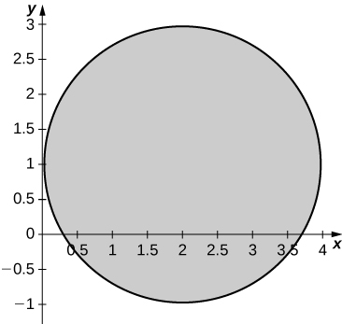

c.

410. **[T]** The transformation  of the form ,  where  is a positive real number, is called a stretch if  and a compression if  in the  Use a CAS to evaluate the integral on the solid  by considering the compression  defined by  and  Round your answer to four decimal places.

Answer:

411. **[T]** The transformation , where  is a real number, is called a shear in the  The transformation, , where  is a real number, is called a shear in the 

1. Find transformations .
2. Find the image  of the trapezoidal region  bounded by  and  through the transformation .
3. Use a CAS to graph the image  in the 
4. Find the area of the region  by using the area of region .

Answer: a. ; b. The image  is the quadrilateral of vertices ; c.  is graphed in the following figure;

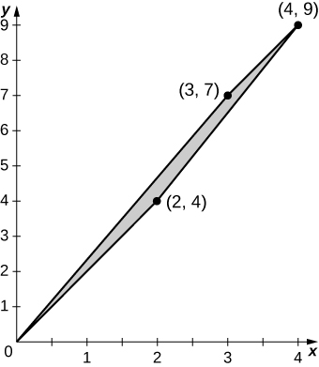

d. 

412. Use the transformation,and spherical coordinates to show that the volume of a region bounded by the spheroid is .

Answer: This is a proof; therefore, no answer is provided.

413. Find the volume of a football whose shape is a spheroid  whose length from tip to tip is  inches and circumference at the center is  inches. Round your answer to two decimal places.

Answer:

414. **[T]** Lamé ovals (or superellipses) are plane curves of equations , where *a*, *b*, and *n* are positive real numbers.

1. Use a CAS to graph the regions  bounded by Lamé ovals for and , respectively.
2. Find the transformations that map the region  bounded by the Lamé oval , also called a squircle and graphed in the following figure, into the unit disk.

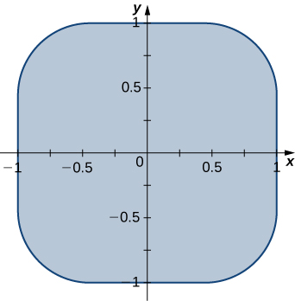

1. Use a CAS to find an approximation of the area  of the region  bounded by . Round your answer to two decimal places.

Answer: a. See the following figures:

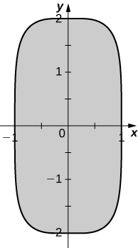 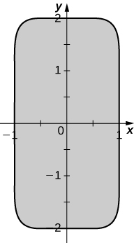

b. c. 

415. **[T]** Lamé ovals have been consistently used by designers and architects. For instance, Gerald Robinson, a Canadian architect, has designed a parking garage in a shopping center in Peterborough, Ontario, in the shape of a superellipse of the equation  with  and . Use a CAS to find an approximation of the area of the parking garage in the case *a* = 900 yards, *b* = 700 yards, and yards.

Answer: 

**Chapter Review Exercises**

***True or False*. Justify your answer with a proof or a counterexample.**

1. 

Answer: False.

1. Fubini’s theorem can be extended to three dimensions, as long as  is continuous in all variables.

Answer: True.

1. The integral  represents the volume of a right cone.

Answer: False.

1. The Jacobian of the transformation for  is given by .

Answer: False.

**Evaluate the following integrals.**

1. 

Answer:

1. 

Answer: 0

1.  where is a disk of radius  centered at the origin

Answer: 

1. 

Answer:

1. 

Answer: 

1. , where 

Answer: 1.475

1. 

Answer: 

1. 

Answer:

1. 

Answer: 

**For the following problems, find the specified area or volume.**

1. The area of region enclosed by one petal of 

Answer:

1. The volume of the solid that lies between the paraboloid  and the plane 

Answer:

1. The volume of the solid bounded by the cylinder  and from to.

Answer: 93.291

1. The volume of the intersection between two spheres of radius 1, the top whose center is and the bottom, which is centered at.

Answer:

**For the following problems, find the center of mass of the region.**

1.  on the circle with radius  in the first quadrant only.

Answer:

1.  in the region bounded by , , and 

Answer:

1.  on the inverted cone with radius  and height .

Answer:

1. The volume an ice cream cone that is given by the solid above  and below 

Answer: 

**The following problems examine Mount Holly in the state of Michigan. Mount Holly is a landfill that was converted into a ski resort. The shape of Mount Holly can be approximated by a right circular cone of height  ft and radius  ft.**

1. If the compacted trash used to build Mount Holly on average has a density  find the amount of work required to build the mountain.

Answer:ft-lb

1. In reality, it is very likely that the trash at the bottom of Mount Holly has become more compacted with all the weight of the above trash. Consider a density function with respect to height: the density at the top of the mountain is still density  and the density increases. Every  feet deeper, the density doubles. What is the total weight of Mount Holly?

Answer:

**The following problems consider the temperature and density of Earth’s layers.**

1. **[T]** The temperature of Earth’s layers is exhibited in the table below. Use your calculator to fit a polynomial of degree  to the temperature along the radius of the Earth. Then find the average temperature of Earth. (*Hint*: begin at in the inner core and increase outward toward the surface)

|  |  |  |
| --- | --- | --- |
| Layer | Depth from center (km) | Temperature |
| Rocky Crust | 0 to 40 | 0 |
| Upper Mantle | 40 to 150 | 870 |
| Mantle | 400 to 650 | 870 |
| Inner Mantel | 650 to 2700 | 870 |
| Molten Outer Core | 2890 to 5150 | 4300 |
| Inner Core | 5150 to 6378 | 7200 |

Answer: average temperature approximately 

1. **[T]** The density of Earth’s layers is displayed in the table below. Using your calculator or a computer program, find the best-fit quadratic equation to the density. Using this equation, find the total mass of Earth.

|  |  |  |
| --- | --- | --- |
| Layer | Depth from center (km) | Density (g/cm3) |
| Inner Core |  |  |
| Outer Core |  |  |
| Mantle |  |  |
| Upper Mantle |  |  |
| Crust |  |  |

Answer: total mass approximately 

**The following problems concern the Theorem of Pappus (see Moments and Centers of Mass for a refresher), a method for calculating volume using centroids. Assuming a region, when you revolve around the  the volume is given by , and when you revolve around the  the volume is given by , where  is the area of . Consider the region bounded by  and above .**

1. Find the volume when you revolve the region around the -axis.

Answer:

1. Find the volume when you revolve the region around the -axis.

Answer: 

This file is copyright 2016, Rice University. All Rights Reserved.